**動機系材導第四次習題(Chap. 7)**

**106年5月8日繳交**

7.41 The circumferential stress, *σ*, (also called hoop stress) in a pressurized cylindrical vessel is calculated by the equation *σ* = *Pr/t*, where *P* is the internal pressure, *r* is radius of the vessel, and *t* its thickness. For a vessel of 36 in diameter, 0.25 in thickness and an internal pressure of 5,000 psi, what would be the critical crack length if the vessel were made of (*a*) Al 7178-T651, (*b*) alloy steel (17-7 pH)?  
What is your conclusion? Use Table 7.1 for properties. (Use *Y* = 1.0 and assume center crack geometry.)

7.43 An ultrasonic crack detection equipment used by Company A can find cracks of length *a* = 0.20 inches and longer. A lightweight component is to be designed and manufactured and then inspected for cracks using the above machine. The maximum uniaxial stress applied to the component will be 60 ksi. Your choices of metals for the component are Al 7178 T651, Ti-6Al-4V, or 4340 steel as listed in Table 7.1. (*a*) Which metal would you select to make the component from? (*b*) Which metal would you choose when considering both safety and weight? (Use *Y* = 1.0 and assume center crack geometry.)

7.44 In problem 7.43, if you did not consider the existence of cracks at all and only considered yielding under uniaxial stress as a failure criterion, (*a*) which metal would you select to avoid yielding? (*b*) Which metal would you select to avoid yielding and have the lightest component? (Use data in Table 7.1)? Is it a safe design practice to assume that no initial cracks exist? Explain.

7.46 An alloy steel plate is subjected to a tensile stress of 120 MPa. The fracture toughness of the materials is given to be 45 MPa⋅m1/2. (*a*) Determine the critical crack length to assure the plate will not fail under the static loading conditions (assume *Y* = 1). (*b*) Consider the same plate under the action of cyclic tensile/compressive stresses of 120 MPa and 30 MPa respectively. Under the cyclic conditions, a crack length reaching 50% of the critical crack length under static conditions (part *a*) would be considered unacceptable. If the component is to remain safe for 3 million cycles, what is largest allowable initial crack length?

7.49 In aircraft applications, aluminum panels are riveted together through holes drilled in the sheets. It is the industry practice to plastically expand the holes to the desired diameter at room temperature (this introduces compressive stresses on the circumference of the hole). (*a*) Explain why this process is done and how it benefits the structure. (*b*) Design a system that would accomplish the cold expansion process effectively and cheaply. (*c*) What are some precautions that must be taken during the cold expansion process?

7.53 Examine the fracture surfaces below and discuss the differences in surface features. Can you identify the type and nature of the fracture?

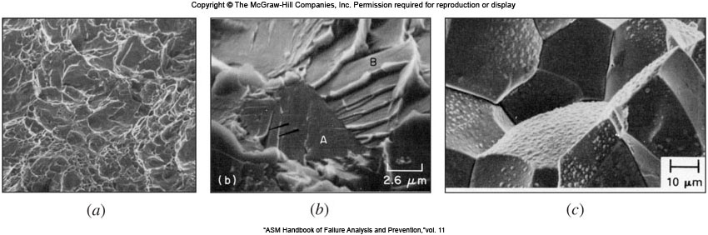

7.54 The components in Fig. P7.54 is high strength steel racecar transmission shaft, which is cyclically loaded in torsion and some bending. The one at the bottom of Fig. P7.54*a* is fractured. Figure P7.54*b* shows a higher magnification image of the fracture path around the shaft. Figure P7.54*c* shows that cross-section of the fractured shaft. Based on this visual evidence speculate as much as possible about what happened to this shaft and where did the fracture start from. Especially, list your observation of Figure P7.54*c.*

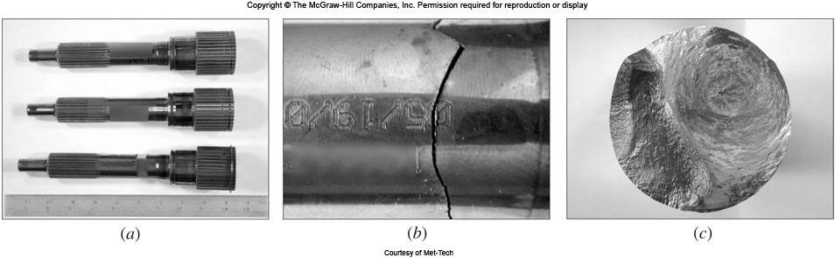

Figure P7.54